Detection of Cuts and Damages on Fish Using YOLOv8

Introduction
The detection of visible cuts and damages on fish plays a critical role in ensuring quality control in supply chain processes. This task forms the first step in a comprehensive fish freshness classification project. The YOLOv8 object detection model is employed at this stage to identify and localize visible damages on fish bodies.

Role in the Fish Freshness Classification Workflow
If damages are detected, the fish is immediately classified as "Bad" with the reason specified as "Damaged," and it is excluded from further processing. However, if no damages are detected, the fish proceeds to the second stage of classification, which involves a CNN-based model that predicts the final label.

Methodology
The workflow of the fish freshness classification system is depicted in the flowchart below. Initially, an image is passed to the YOLOv8 model for cut and damage detection. If damages are detected, the fish is labeled as "Bad" with the reason specified as "Damaged." However, if no damages are identified, the image proceeds to the next stage, where a CNN-based model predicts the final freshness label.
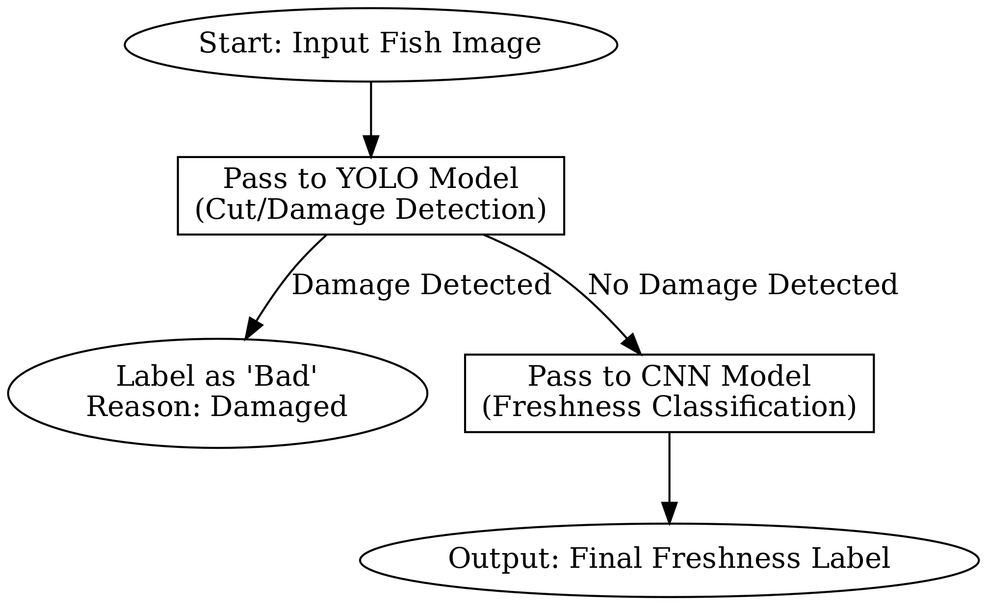

Dataset Preparation and Pre-processing
The YOLOv8 model was trained on a dataset comprising 1131 annotated images, including 831 images for training and 300 for validation. The images were pre-processed to focus on the fish body, with the background replaced by white pixels to enhance clarity. The original aspect ratio of the fish was preserved, and all images were resized to dimensions of 640x640 pixels to meet the input requirements of the model. The annotations were created using Roboflow to ensure accurate bounding boxes for damaged regions.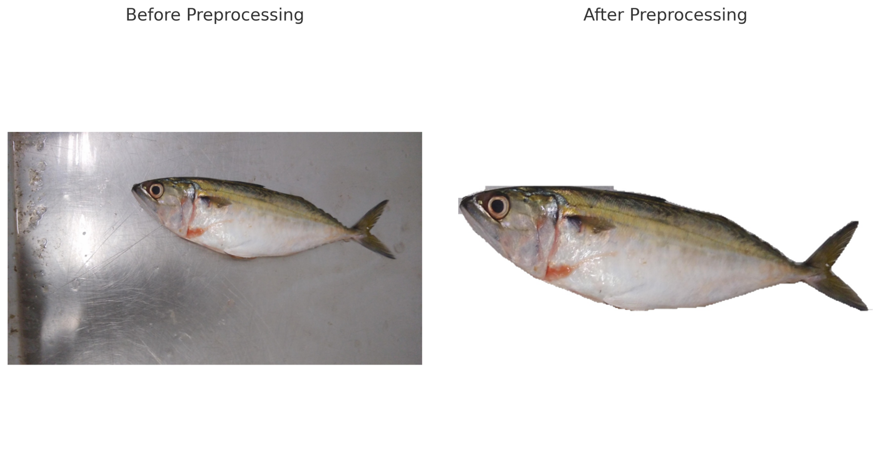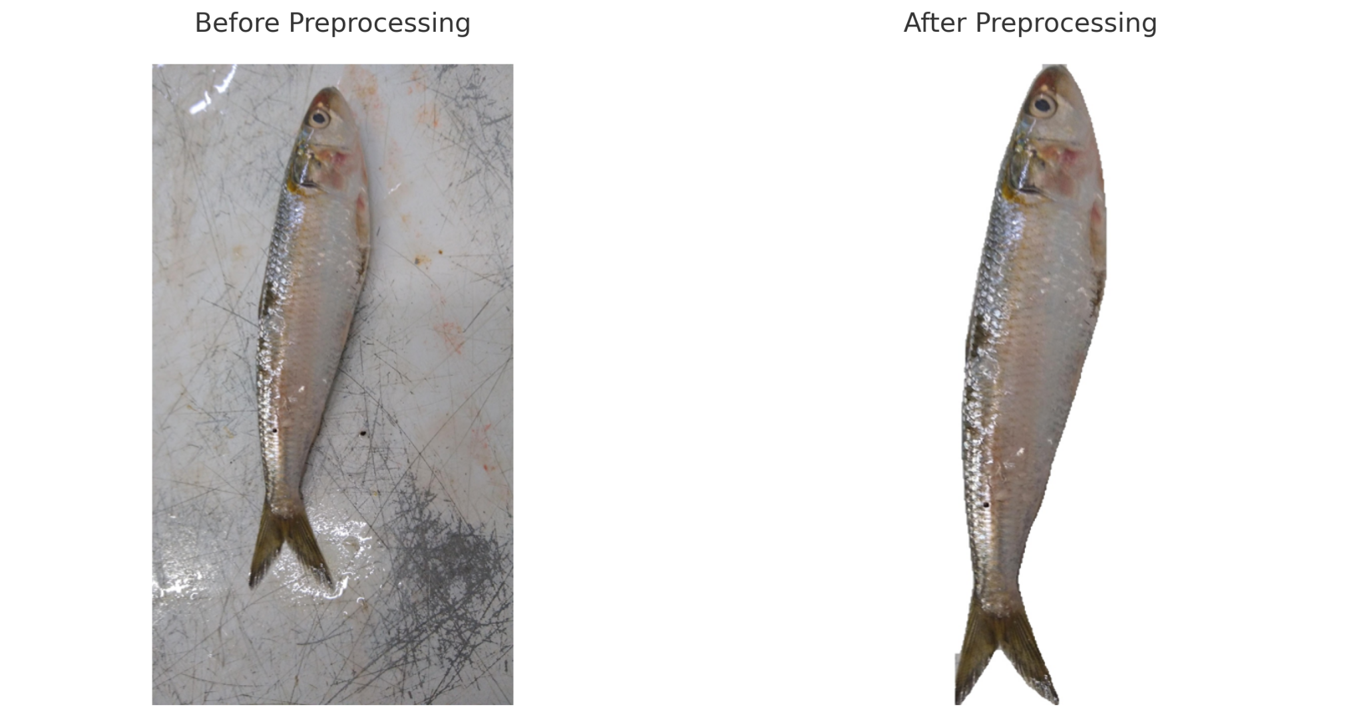

Model Training
The training process consists of 100 epochs, during which data augmentation techniques, including flipping, rotation, HSV (hue, saturation, value) adjustments, and mosaic augmentation, were applied to simulate diverse scenarios and improve model generalization. Key loss functions, including box loss, classification loss, and distribution focal loss, were optimized to enhance the model's ability to detect and localize damages effectively.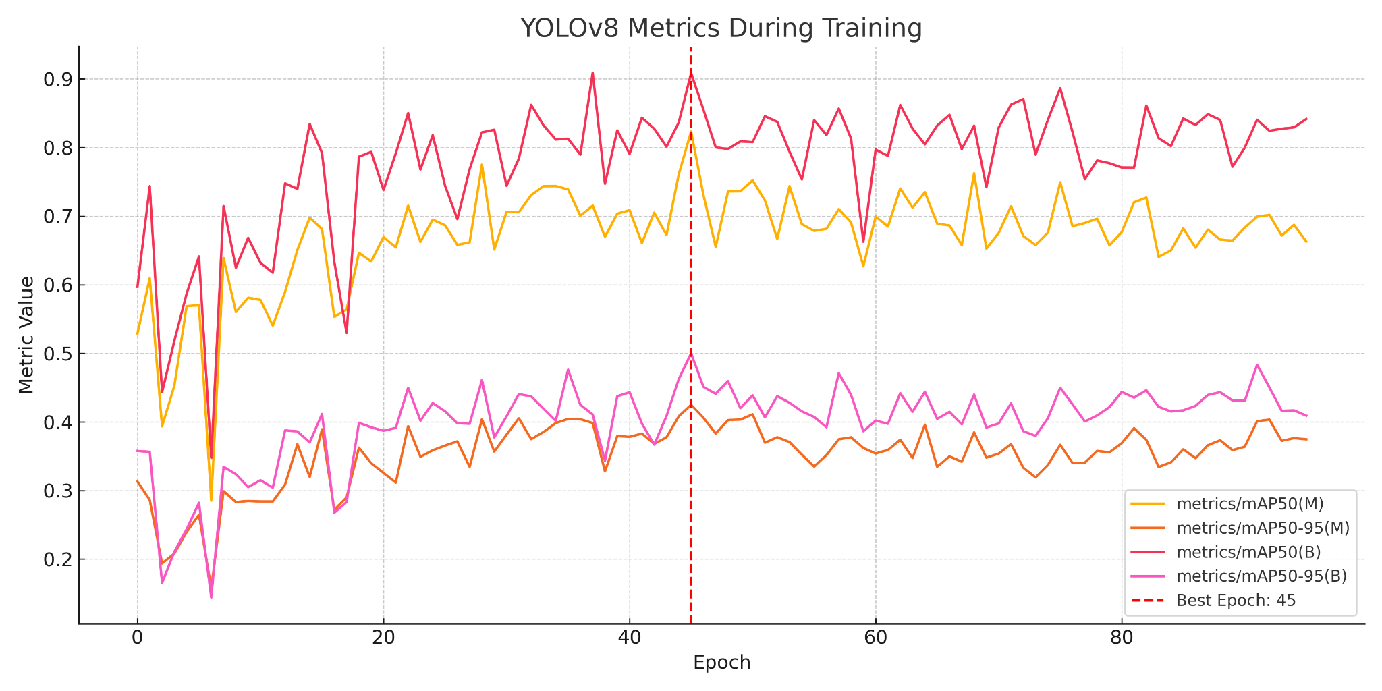
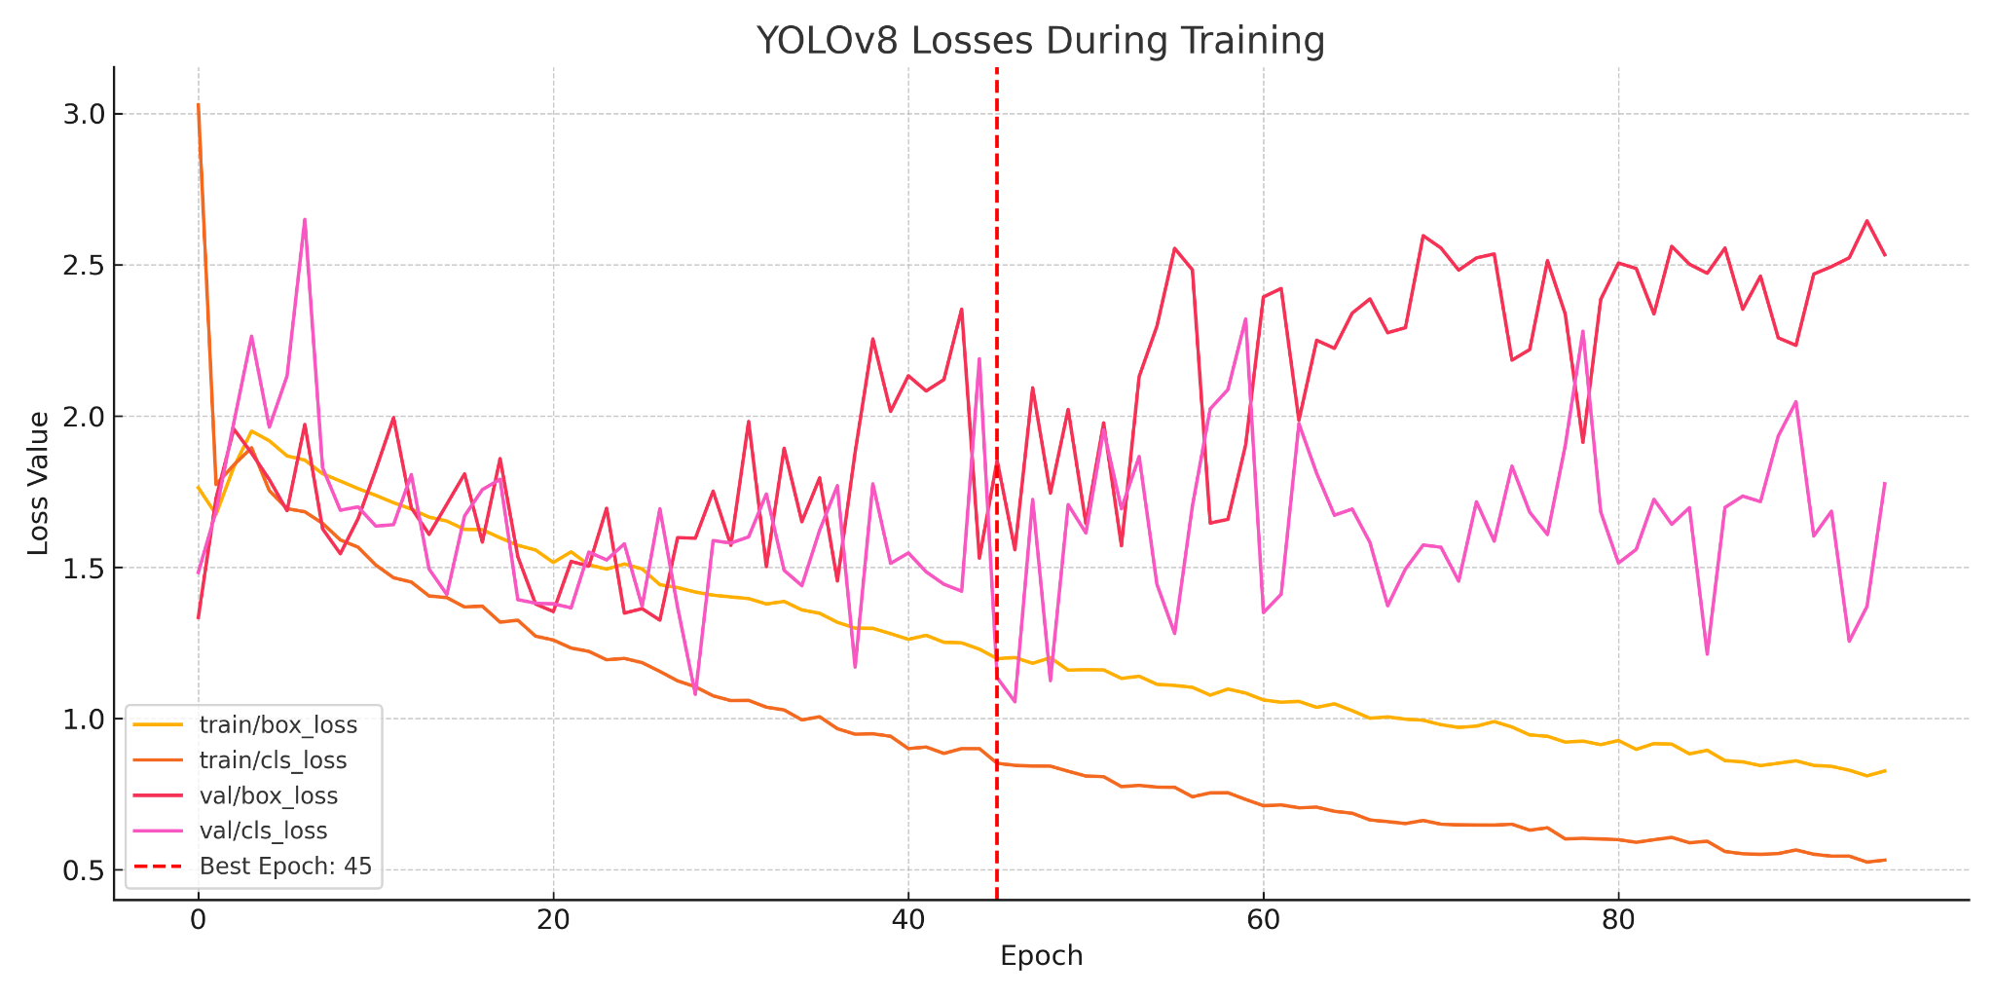

Model Evaluation
The evaluation of the YOLOv8 model was conducted using metrics such as mAP@0.5, mAP@0.5:0.95, precision, and recall. The mAP@0.5 for the damage class reached 82.3%, while the stricter mAP@0.5:0.95 achieved 42.5%, indicating a strong performance in both detection and localization of damages. For the background class, the mAP@0.5 and mAP@0.5:0.95 were 90.9% and 50.0%, respectively. Precision for the damage class was recorded at 83.0%, with a recall of 75.0%, while the background class demonstrated a precision of 93.0% and a recall of 83.3%.

Results and Analysis
The confusion matrix analysis revealed 254 true positives for damage detection, alongside 46 false positives and 18 false negatives. For this analysis, we used 300 images of non-damaged fish and 300 images of damaged fish. These results highlight the model's sensitivity to damaged regions and its ability to distinguish between damaged and non-damaged areas effectively. The high precision and recall values further confirm the reliability of the YOLOv8 model as a critical tool in fish quality control.
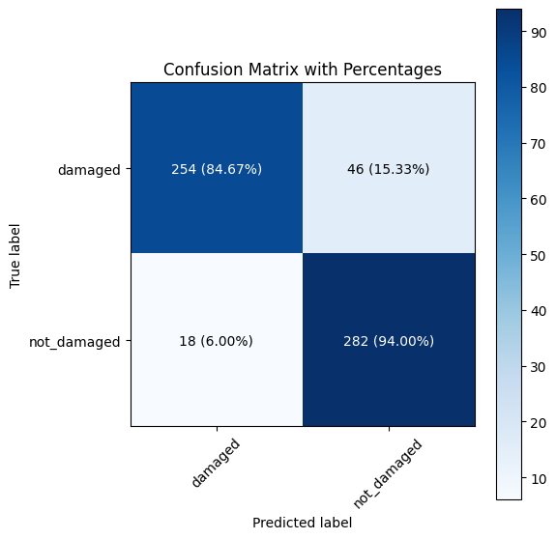
Below are examples of the YOLOv8 model detecting damages on fish with bounding boxes and confidence scores:
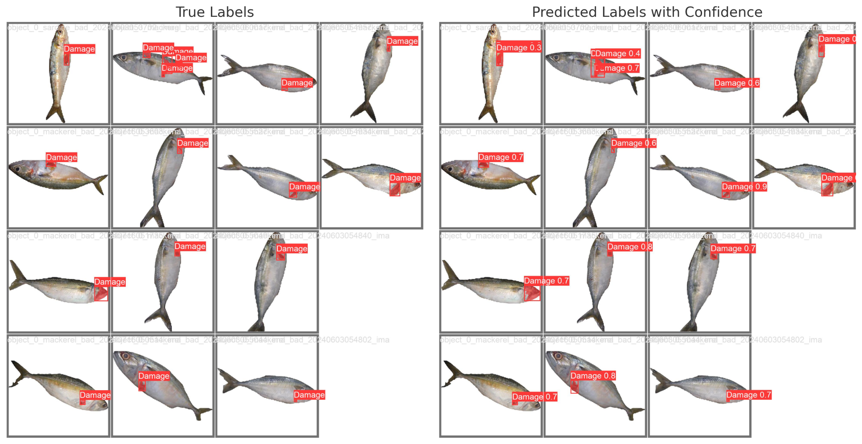

Conclusion
This model serves as the first level in the overall fish freshness classification system. Its ability to accurately detect damages ensures that visibly damaged fish are immediately labeled as "Bad" and removed from further processing. Fish without detected damages are passed to the second stage, where a CNN-based model performs a more detailed analysis to predict the final label. The integration of the YOLOv8 model in this pipeline demonstrates its effectiveness as a critical decision-making component in automating fish quality assessment. Its strong detection performance establishes a reliable foundation for the subsequent stages of the classification workflow.

References
[1] Ultralytics, "YOLOv8 Object Detection Model," [Online]. Available: https://github.com/ultralytics/ultralytics.
[2] Roboflow, "Dataset Annotation and Management Platform," [Online]. Available: https://roboflow.com.

Attempt to write compact summary of damage detection model:

The YOLOv8 model is pivotal as the initial stage of a fish freshness classification pipeline, focusing on detecting visible cuts and damages on fish species like Sardine and Mackerel. Leveraging 1131 annotated images (831 for training, 300 for validation) prepared using the Roboflow platform, the model achieved mAP@0.5 of 82.3%, ensuring accurate damage identification. Fish detected with damage are labeled as "Bad" and excluded from further evaluation, while undamaged fish are forwarded to a CNN model for freshness classification. This two-tier system ensures precise and efficient fish quality assessment.

